Guideline for SISPAD 2025

line 1: 1st Given Name Surname   
line 2: *dept. name of organization   
(of Affiliation)*  
line 3: *name of organization   
(of Affiliation)*line 4: City, Country  
line 5: email address or ORCID line 1: 2nd Given Name Surname  
line 2: *dept. name of organization   
(of Affiliation)*  
line 3: *name of organization   
(of Affiliation)*line 4: City, Country  
line 5: email address or ORCID line 1: 3rd Given Name Surname  
line 2: *dept. name of organization   
(of Affiliation)*  
line 3: *name of organization   
(of Affiliation)*line 4: City, Country  
line 5: email address or ORCID

*Abstract*—This electronic document is a “live” template and already defines the components of your paper [title, text, heads, etc.] in its style sheet. (*Abstract*)

Keywords—component, formatting, style, styling, insert (key words)

# Introduction (*Heading 1*)

This document is a proposed template and guideline for SISPAD 2025. It is based on IEEE template example. For more details, please refer to the IEEE template example available at <https://www.ieee.org/conferences/publishing/templates.html> .

# SISPAD 2025

The International Conference on Simulation of Semiconductor Processes and Devices (SISPAD) [1] provides an international forum for the presentation of leading-edge research and development results in the area of process and device simulation. SISPAD is one of the longest-running conferences devoted to technology computer-aided design (TCAD) and advanced modeling of novel semiconductor devices and nano electronic structures. SISPAD 2025 will be held in-person in Grenoble, France, from September 24 to 26, 2025.

A satellite workshop will be offered on the day before the main conference starts (September 23).

Details on the SISPAD 2025 technical program and workshop will be announced here as soon as they are available.

We hope to see you in Grenoble, France in September.

SISPAD 2025 Committee.

# Presentation Type and Requirements

## Presentation type (Heading 2)

SISPAD 2025 will be held in-person and accepts oral and poster presentations.

Final determination of the presentation type will be made by the Technical Program Committee.

## Requirements

* Deadline for submission: <https://sispad2025.inviteo.fr/>
* All abstracts must be written in English.
* Please complete the abstract in 2 pages (A4 portrait, including tables and figures), and the file size must be less than 10 MB.
* 10 - 12 point font is recommended.
* Abstracts sent by e-mail or postal mail will NOT be considered.
* You can NOT use 2 byte font such as Japanese, Korean, Chinese characters or 1 byte font of Asian characters such as MS Gothic, MS Mincho, Ryumin, Batang etc.

# Full Submission Information

Full submission information will be posted on this website at a later date.

Camera-ready copy of a four-page manuscript will be required from the authors for inclusion in the Conference Proceedings by June 24 2025.

Since notification of acceptance and further announcements will be sent only to the abstract submitter's registered email address, we strongly recommend each presenting author to create his/her own account and submit his/her abstract(s) from that account.

##### References

1. SISPAD Committee, “SISPAD Website”. [Online]. Available : <https://sispad2025.inviteo.fr/>

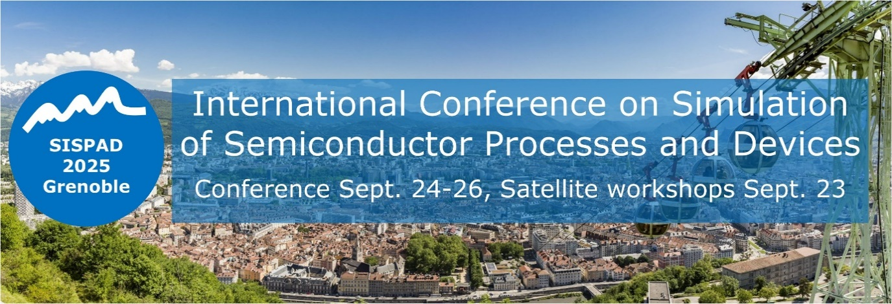

1. Example of a figure caption. (*figure caption*)